Module #: | Module 1
Module Title: | Generating an achievement report using TMOA as the progress and achievement marker.
Presenter 1 Name:  Iwi:  Title: | Makere Karatea  Ngāti Kahu, Nga Puhi, Te Rarawa, Te Aupouri  Kia Ata Mai PLD Facilitator
Presenter 2  Name:  Iwi:  Title: | Louise Keepa  Ngāti Awa, Te Arawa  Kia Ata Mai PLD Facilitator
Slide 1  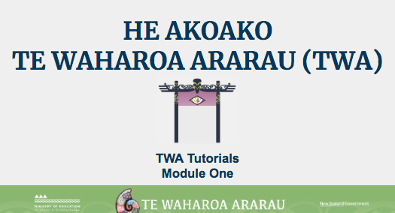 | Kei aku rangatira huri noa i Aotearoa e mātaki mai ana, tēnā tātou katoa. Nau mai ki tēnei akoako poto e pā ana ki te whakahoutanga o Te Waharoa Ararau.
Slide 2  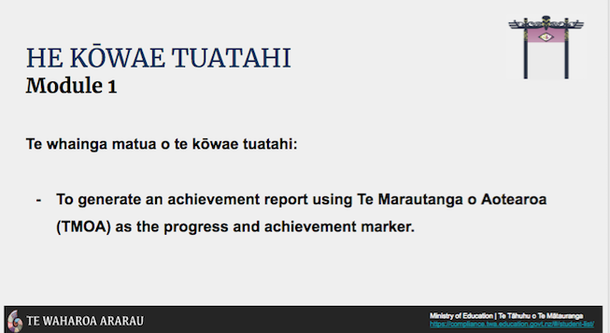 | In this tutorial, we will be demonstrating how to generate a report using Te Marautanga o Aotearoa as the progress and achievement marker.
Slide 3  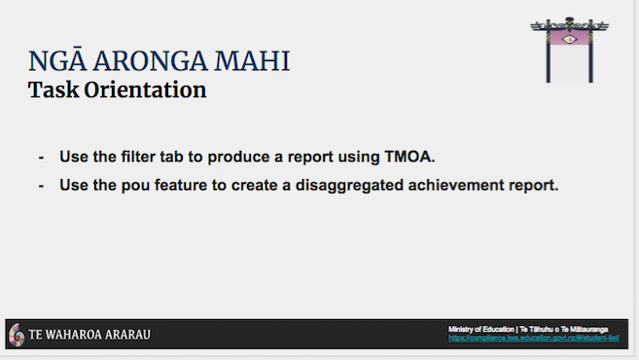 | By the end of this tutorial you’ll be able to: use the filter tab ‘Ngā tātaringa’ to produce a school wide report in relation to Te Marautanga o Aotearoa outcomes. You will also be able to use the table headings to organise disaggregated achievement information for reporting purposes. Now we’re going to look at some of the recent changes to Te Waharoa Ararau.
Changes in Tab Format | Once logged into Te Waharoa Ararau, click on the Pūrongo tab to explore recent changes.  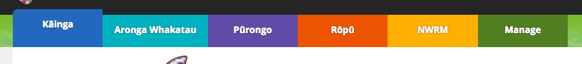
Pūrongo Tab | In the Pūrongo tab, click the filter tab Ngā Tātaritanga. Select the filter options that apply to the report you’re wanting to create. The default progress and achievement marker is Te Marautanga o Aotearoa. By selecting the Te Marautanga o Aotearoa filter, the user is able to generate an achievement report in relation to Te Marautanga o Aotearoa Taumata tahi ki te rima. Then click whakaae.  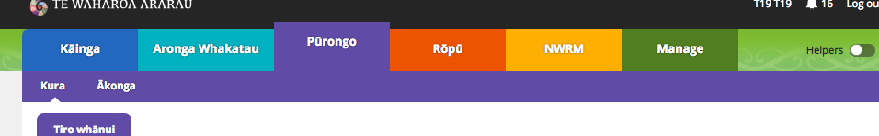
Summative graph for all students (or if you have selected a specific group then the graph will show this information) | Te Waharoa Ararau will then produce a bar graph aligned to the selected filters. The bar graph displays the numbers and percentages of ākonga achieving at each Te Marautanga o Aotearoa taumata. The colours in the bar graph align to the different Te Marautanga o Aotearoa taumata. For example there are 26 ākonga or 12.3% of ākonga achieving at taumata rua.  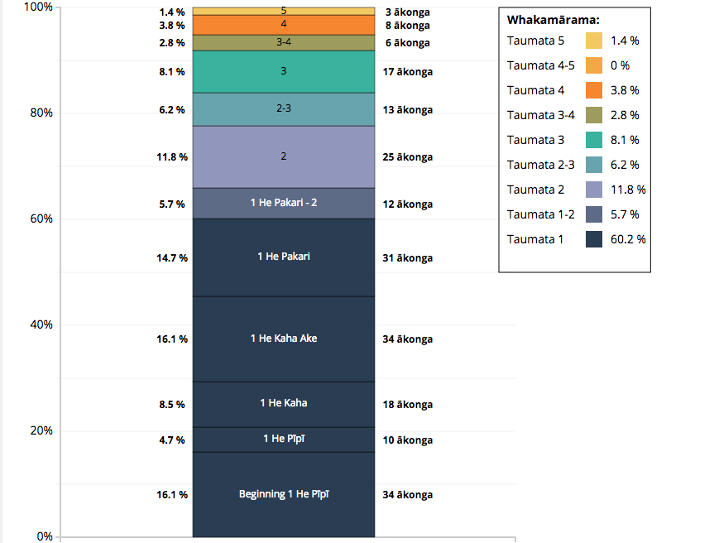
Disaggregated data by individual student | As in the previous iteration of Te Waharoa Ararau, the individual ākonga profiles and corresponding Te Marautanga o Aotearoa taumata are displayed in the table below. This new feature shows ākonga achievement in relation to Te Marautanga o Aotearoa taumata tahi ki te rima.  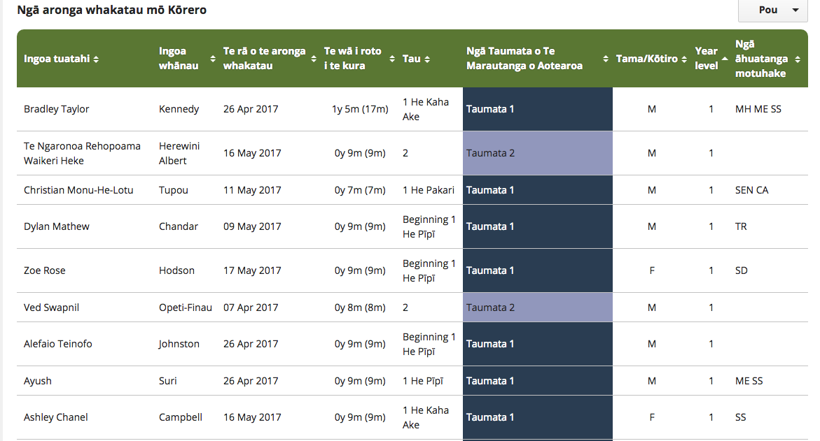
Using tab headings in the table to help organise achievement information for reporting purposes | Utilising the table headings enables the user to organise achievement information for reporting purposes. By clicking on ‘Ngā taumata o Te Marautanga o Aotearoa’ tab in the table headings, Te Waharoa Ararau will organise achievement information in a descending or ascending order.
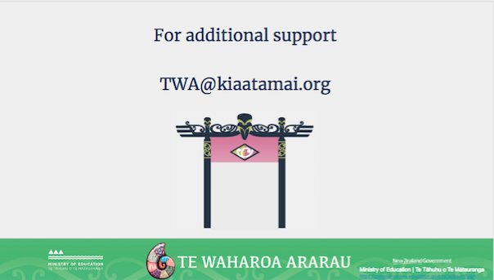 | For additional support with queries and issues as they arise, you can contact the TWA email helpline on TWA@kiaatamai.org
Slide 5  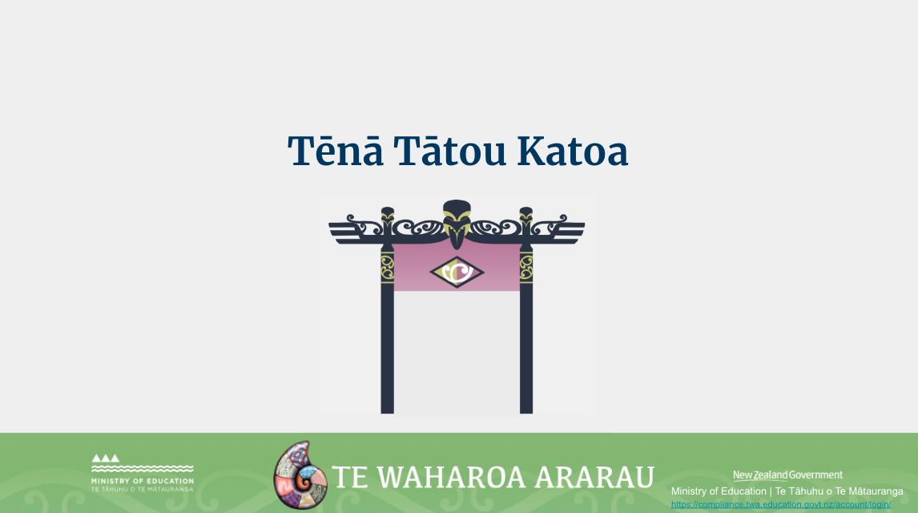 | Ko te manako ia, kua whai hua koutou i tēnei akoako poto me ngā kai o roto. Nei rā te mihi manahau ki a koutou katoa.

